**UNIVERSITY OF LONDON INTERNATIONAL PROGRAMMES**

**BSc Computer Science and Related Subjects**



**CM3070 PROJECT**

**PRELIMINARY PROJECT REPORT**

Dystopian Document Thriller

Author: Ng Yung Qi

Student Number : 10245771

Date of Submission: 17 June 2024

Supervisor : Sarita Singh

Contents

CHAPTER 1: INTRODUCTION 3

CHAPTER 2: LITERATURE REVIEW 3

CHAPTER 3: PROJECT DESIGN 4

CHAPTER 4: PROTOTYPE IMPLEMENTATION 6

CHAPTER 5: REFERENCES 9

# INTRODUCTION

Motivation

Set in the midst of the pulsating nightlife in a dystopian city, the game provides a perfect backdrop for a thriller game that combines the responsibilities of a nightclub bouncer with the suspense of a murder mystery. The setting offers an engaging environment where players can experience the duality of maintaining order and solving crimes.

Aims and Objectives

The aim of this project is to develop an immersive narrative driven game that puts players in the role of a nightclub bouncer.

The objectives include:

* An engaging storyline that intertwines nightclub management with a murder mystery.
* Gameplay mechanisms that require players to check identification cards and watch out for potential suspected serial killers.
* Incorporating important decision-making processes that mean life or death.
* Stylized level of graphical cohesion and atmospheric design to enhance player immersion.

# LITERATURE REVIEW

Comparison 1: Narrative-driven Games

**Study**: F. Amiri (2021), Narrative in Story-Driven Video Games: A Comparative Study of Emergent, Embedded and Mixed Narrative Techniques

**Key Takeaway**: Rich storytelling significantly increases immersion and emotional connection for players to the game. Giving players the ability to affect the game’s trajectory with their actions grants a greater sense of immersion and an increased amount of emotional attachment to the game.

Comparison 2: Roleplaying Mechanisms

**Study**: T. Zinovieva (2024), Emotional Intelligence in Game Elements for Forming Higher Feelings in Active and Deeper Learning

**Key Takeaway**: Roleplaying elements, such as decision making and character development, are substantial for player engagement as it ties in heavily to emotional intelligence, which results in higher player retention.

Comparison 3: Game Mechanisms

**Study**: J. Pi (2024), Game Theory and Game Mechanics Design

**Key Takeaway**: A well-crafted game should have a sense of balance. The study speaks about the ‘prisoner's dilemma’ and how it could affect the player’s experience within the game. Keeping a balance between storytelling and game mechanics is crucial to providing a pleasant experience overall.

Comparison 4: User Interaction in Games

**Study**: Y. Feng (2024) The Important Role of Multiple Endings on Game Immersion

**Key Takeaway**: Interactive mechanisms, such as branching dialogues and multiple endings, facilitate player satisfaction and game replayability. Quote, “evident that the significance of many endings in enhancing the immersive experience of the game cannot be overlooked.” The study focused on a game named ‘The Witcher III: Wild Hunt,’ which is notoriously known for its branching paths and different endings depending on the choices of the player.

# PROJECT DESIGN

Software Tools and Techniques

To develop the Dystopian Document Thriller game, I will be using the following tools and techniques:

* Unity Engine: Game development.
* Photoshop: Texturing, map tiles, and graphic design.
* C#: Scripting and game logic.
* Playtesting and Bug Fixes: Conduct playtesting and gather player feedback.

Domain and Users

The game targets adults who enjoy thriller and mystery games, particularly those interested in roleplaying and narrative driven games that provide a challenge.

Methodology

I will be using an iterative development methodology that will aid in focusing on continuous improvement through player feedback and testing.

Phases

1. Concept: Brainstorm ideas, game mechanics, storyline, and design.
2. Prototyping: Develop initial prototypes for the game such as assets and base mechanics.
3. Development: Implement core game mechanics, narrative elements, and player interactions.
4. Testing: Conduct playtesting sessions to gather user feedback, report bugs, and identify areas for improvement.
5. Finalization: Polish the game based on feedback, and fix bugs in preparation for release.

Evaluation

Evaluation will involve qualitative and quantitative methods such as feedback surveys and gameplay analytics which will aid to further improve the game, storyline, and its mechanics.

Testing

I will conduct testing by organizing playtesting sessions with my peers to ensure all aspects of the game function correctly and provide a satisfying player experience.

Gantt Chart

# PROTOTYPE IMPLEMENTATION

Initial Steps

The initial implementation involved creating basic character models, user interface assets, the nightclub background environment, and the main base mechanic of the game.

***Initial Non-Player Character Models:***

I took inspiration from 8-bit styles and worked in photoshop to create multiple versions of character models. Below is a screenshot of some of the models I made for the patrons that will queue up outside of the nightclub. These models will be used as a core element of the game where the player will have to match up their appearance to their identification cards. I included various positions as well for idle and walking animation purposes.

***Nightclub Game Environment:***

This was a free asset I found on the itch.io store by a user named ‘Ansimuz.’ I made some alterations to the alleyway in photoshop by removing a neon sign and a back entrance and replaced it with trash bins instead as I felt like it was drawing too much attention away from the bar’s entrance to the right. Further improvements might include the addition of animations to the background.

*First iteration:*

*Second iteration:*

***Game Assets:***

This is the first iteration of the clipboard pages that will be an important game element as it acts as a guide for the player by providing rules on what to look out for when checking identification cards.

**

***Identification Card Assets:***

For the identification cards, I created them from scratch in Photoshop. Each card has the full name, sex, date of birth, place of birth, photo of the owner, and a barcode. Some of the cards have subtle discrepancies which are intentionally placed to function as hints for the player in their decision making throughout the game.

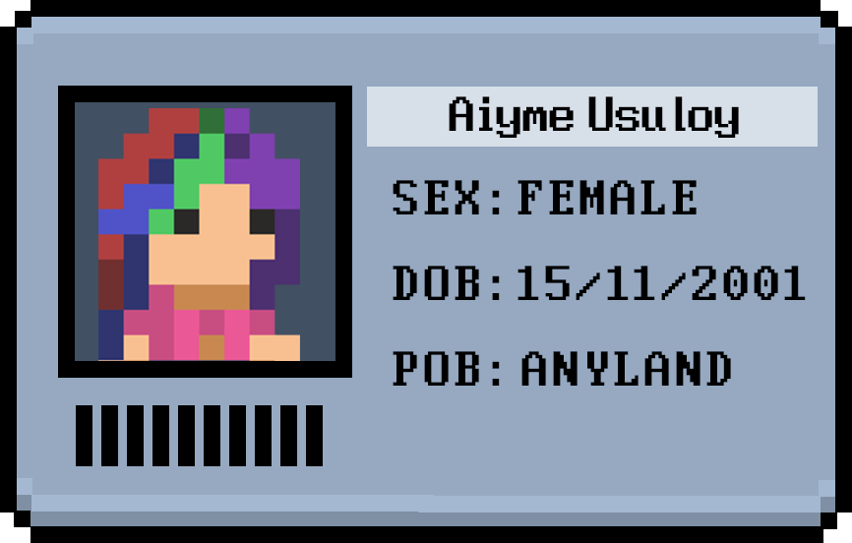

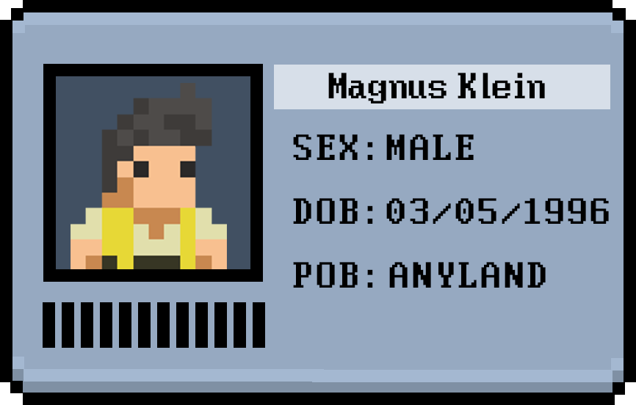 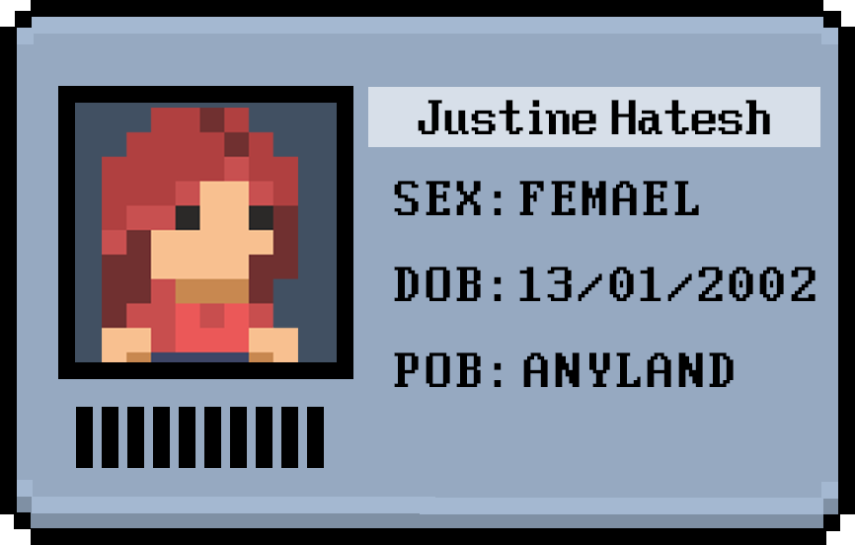

***Game Base Mechanic Prototype:***

When the game begins after the player clicks the start button, the camera pans down slowly to reveal the work area where they will view the clipboard, the patron’s identification card, and the two buttons that allow them to make the choice of either letting the patron into the nightclub or turning them away. In the screenshot below, clicking on the green square button returns the log “YES” in the console, and the name of the identification card object. Further logic implementation will be added to check whether the player made the right or wrong choice. Additionally, the player is able to click the arrow button at the bottom of the clipboard to turn to the next page, which is the guest list.

Here, clicking on the red button will return “NO,” indicating that the player has chosen not to let the patron into the nightclub.

# REFERENCES

* F. Amiri (2021), Narrative in Story-Driven Video Games: A Comparative Study of Emergent, Embedded and Mixed Narrative Techniques
* T. Zinovieva (2024), Emotional Intelligence in Game Elements for Forming Higher Feelings in Active and Deeper Learning
* J. Pi (2024), Game Theory and Game Mechanics Design
* Y. Feng (2024) The Important Role of Multiple Endings on Game Immersion
* <https://ansimuz.itch.io/cyberpunk-street-environment> (Game background Asset)